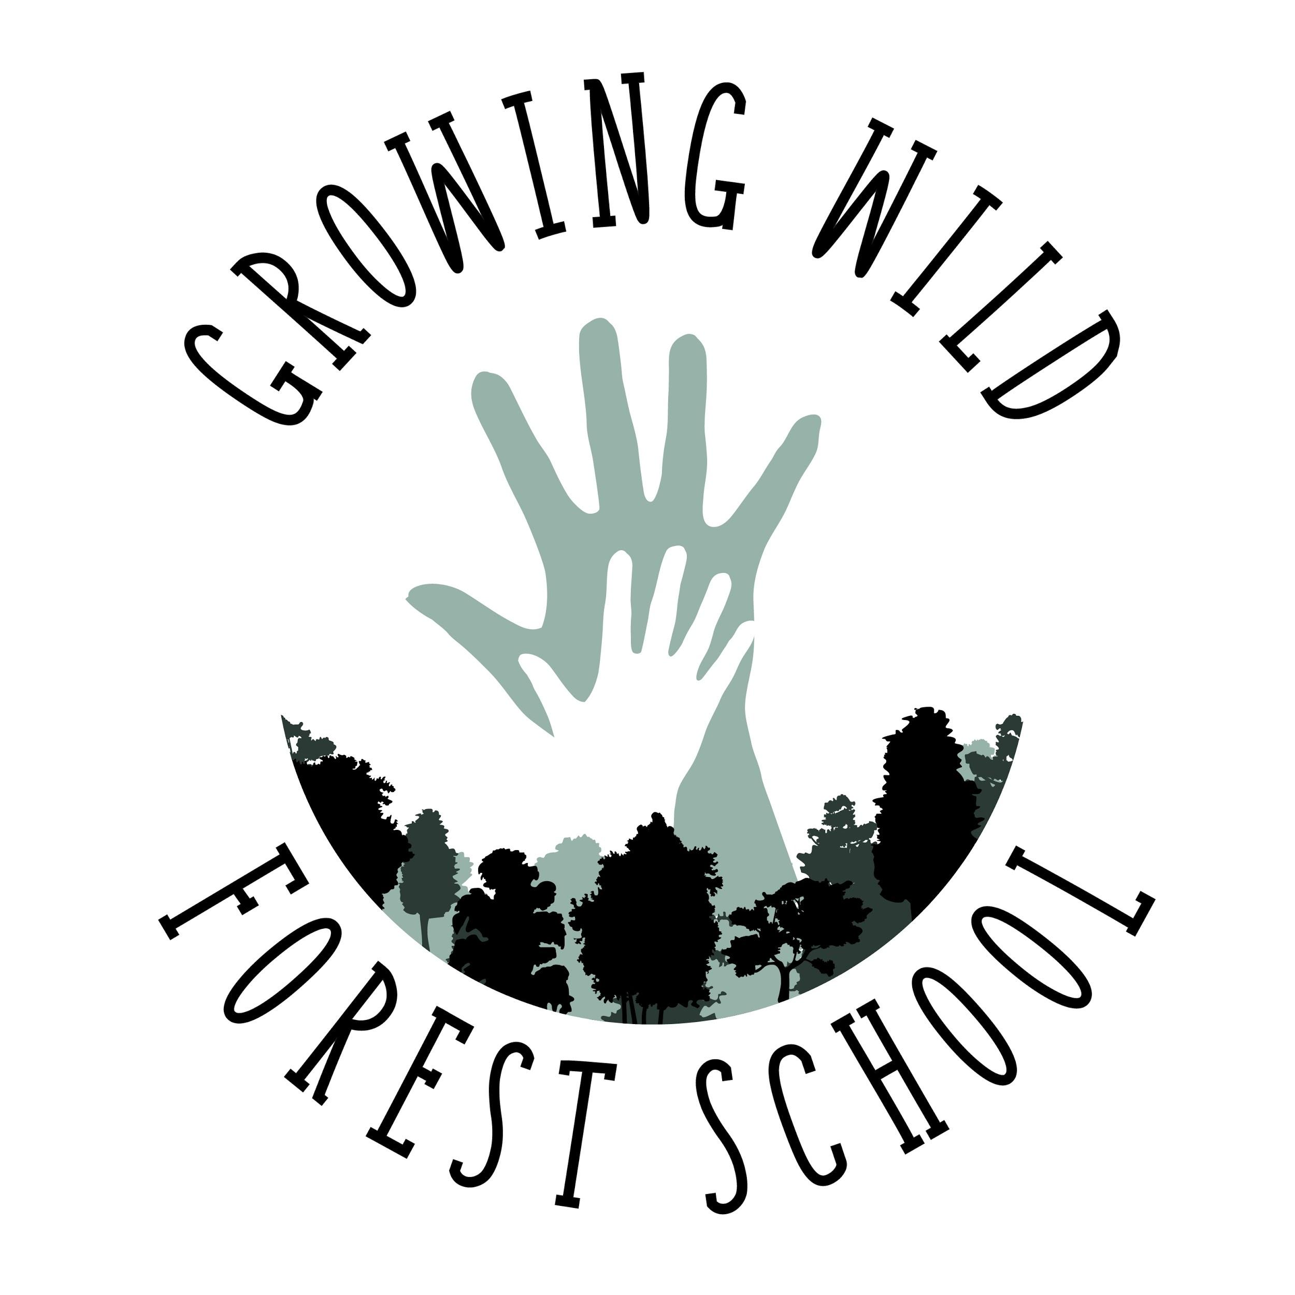

Growing Wild Forest School
Family Handbook
2019-20

Every day in the forest is a gift, and the staff of Growing Wild Forest School are grateful to share that gift with children. Our school has no walls, and our ceiling is the wide sky; that means the container of our school is held by the adults present. The consistent daily rhythm and set of agreements introduced here help to maintain a compassionate and safe container for young children to play, grow, and learn.

Young children are fully human beings learning how to navigate the world for the first time, and a village of compassionate adults must support them in this learning. This means that parents, teachers, and children are all on the same team. We model and encourage honest communication between all.

1. Schedule:
We meet Monday through Friday. Drop-off is at 9:30 am, and the flow of our day begins at approximately 9:45. Pick-up is at 1:30 pm. Teacher-parent co-op aftercare is available until 3:30 pm. The group meets at Base Camp, in the backyard of the Unity Church of Asheville. We generally follow the Buncombe County Schools schedule.

2019-20 Sessions and Breaks
Sessions
Fall Session: Mon. Aug. 26, 2019 - Fri. Dec. 20, 2019
Winter Session: Mon. Jan. 6, 2020 - Fri Mar. 20, 2020
Spring Session: Mon. Mar. 23, 2020 - Fri. Jun. 12, 2020
Summer Session: Mon. Jun. 15, 2020 - Fri. Aug. 21, 2020
​
Breaks
Thanksgiving Break: Mon. Nov. 25, 2019 - Fri. Nov. 29, 2019
Winter Break: Mon. Dec. 23, 2019 - Fri. Jan. 10, 2020

2. Inclement Weather Policy:
We closely monitor local wind speed, heat index, electrical storm activity, windchill, and ice and snow, and we will cancel school if conditions are unsafe for driving or for playing outside for four hours among big trees.
We will cancel school for gusts predicted at 25 mph or higher, lightning within 5 miles, heat index of 100 degrees F or higher, and windchill of 15 degrees F or lower. Teachers will inform parents that school is delayed or cancelled for the day via text message by 8:00 am at the latest.
In case of unexpected lightning or dangerous wind, teachers bring children into the outdoor-access basement stairs of the church and call parents to pick children up.

3. Enrollment and Tuition:
We send invoices through Wave, a third-party accounting software, on the 20th of the month for the following month’s tuition.Tuition is paid as donation to The Forest School Foundation, our parent nonprofit organization. If you would prefer not to use the billing software, checks can be made out to The Forest School Foundation.

To attend five days a week: $720/month​
To attend four days a week: $576/month​
To attend three days a week: $432/month​
To attend two days a week: $288/month​
To attend one day a week: $144/month

A $25 fee is due with the application.To be fully enrolled, each family must return the completed Application, Parent Handbook Acknowledgement, and the Student Release Form.

4. Emergent Curriculum:
Growing Wild Forest School uses a play-based, child-led, interest-directed emergent curriculum that observes seasonal changes. Crafts, games, and activities that fall within a monthly theme are made available, but are not compulsory. This follows the wealth of development research showing that the best environment adults can create for children’s learning is allowing plenty of free play with minimal adult interference, but with adults nearby Teachers observe children’s themes of play and areas of interest, and support those with materials and stories tying into the seasonal changes surrounding us each month.

5. Proper Clothing:
Children will get dirty in forest school, and sometimes they will get wet. Please help children choose clothing for the day that may get dirty, possibly ripped or stained. Also, help children choose clothing (including shoes) that they can put on and take off by themselves, even if it takes them some time; dressing oneself fosters a deeply important sense of accomplishment and self-efficacy.

Guidelines for weather-appropriate dress can be found here: https://docs.google.com/document/d/1yJHNaIz-j9y8TU1xAmVZErceopXAAgy61HHoeoJ_-nc/edit?usp=sharing

During warmer months when days are above 60 degrees, we permit children to go barefoot if they choose at Base Camp. Children must wear shoes when down on the Greenway.

***PLEASE LABEL YOUR CHILD’S CLOTHING WITH THEIR NAME***

6. Sign In/Out:
Parents/guardians must sign each child in and out every day, because North Carolina state law requires that we closely track the time your child is in our school. Signing in/out must include the child’s name, the date and time, and a signature. Our days run from 9:30 am to 1:30 pm. Depending on interest and demand, a parent co-op can be formed for aftercare from 1:30 pm to 3:30 pm.

7. Typical day:
Teachers and volunteers arrive to the site a minimum of a half hour before the families are due to arrive. Teachers walk and scout the areas where the day is planned to be, and set up any supplies or structures necessary (rope swings, rain shelters, fire.)

Teachers have backpacks to carry necessary items such as tarps, blankets, rope, tools, first aid kit, potty-in-the-woods kit, craft supplies, cooking supplies, snacks, field guides, etc.

Teachers and volunteers greet arriving families and help facilitate goodbyes, and parents sign their children in with the date and time. The first portion of the day is free play with some offered activities. Children and teachers communicate over distances using animal calls that mean “show me where you are” and “come back right now.”

After free play, we form our opening circle. We sing each child into the circle by name, and recognize any who are absent. We then sing several songs with accompanying body movements. These songs may change with seasons or with children’s evolving needs. We also invite awareness of the natural world with all of our senses during this gathering. The opening circle is a centering, grounding “in-breath” meant to establish the group relationship and provide a solid foundation to the day.

After our opening circle, we set up for snack. We sing our blessing song before we eat. Snack time is also tea time, which is a ritual that includes real teacups. We discuss what we’ll be doing that day, bearing in mind that plans can be flexible according to the needs of all present. We garden, craft, play games, meet new plants and animals, or go on walks (adventures.) Children may leave the snack blanket when they have cleaned up their area.

The children are then free to play as they want, before we come back together for the planned activities. This may include walks down to the Hominy Creek Greenway. Group cohesiveness on walks is maintained with previously discussed expectations, songs, and games. During this free play time, teachers and volunteers have hand work such as gardening or sewing, and children can also work with them if they choose. This is an “out-breath” during our rhythm of the day.

We then come together for lunch. Our lunch ritual is similar to snack- we sing a gratitude song before lunch, and then we turn over a 3-minute sand timer and eat silently until the timer runs out. After that, we can talk, tell stories, and pack up our things when we’re done. This is another “in-breath,” which is followed by an “out-breath” of free play and games. As pick-up time draws near, we pack up our belongings and come back together for a closing circle.

Families are encouraged to socialize with each other at pick-up time. When teachers and volunteers have connected each child to their caregiver and given information about the day, they separate from the group of families to go over the events of the day and plan for the future.

The in-breath, out-breath rhythm of the day remains consistent throughout the year.

8. Records:
Throughout the weeks, teachers and volunteers take note of milestones in each child’s development. These assessments are based on national standards and research, and are noted only via observation- teachers can introduce group activities that reveal certain developmental milestones, but children will not be formally tested. These observations can be presented to parents in ongoing conversations, and formally halfway through the school year and at the end of the school year.
Records are confidential and will be kept for a maximum of five years. These include all forms signed, including medication instructions.

9. School Agreements (Good Manners):
Our school agreements are Be safe, Be gentle, Be kind. Growing Wild Forest School is based on mutual love, compassion, and respect for the natural world, including each other. This means that we use good manners with all living things. We use kind words and gentle hands with plants, animals, and each other. We especially look out for those who are smaller, younger, or less able than we are; this includes plants and animals as well as younger children. We clean up after ourselves and take good care of our belongings and others’ belongings.

We believe that compassionate and respectful adults were once children who were given plenty of opportunities to make loving and respectful choices on their own. Sometimes young children are so overwhelmed with a big emotion that they forget to use good manners, and when that happens teachers are there to remind them of our agreements and help them if necessary.

Sharing and turn-taking are not enforced in Growing Wild Forest School. Teachers may verbally comment on how much fun a child seems to be having with an object and muse that they’d probably love to see that same look on their friend’s face, but teachers do not force children to share. Children can wait until their friend is done using an object before they have a turn. Sometimes it’s hard to wait, but waiting for something we want is a skill that must be practiced. This is an excellent arena to practice expression of wishes, negotiation, and other social skills! Sometimes through this, we also learn that a person who is hoarding all of the goods never has a happy look on their face, because it actually feels much better to share something fun.
In order to set up such invaluable social/emotional practice, teachers sometimes intentionally create scarcity of desired objects.

10. Bathroom:
Children attending Growing Wild Forest School must be out of diapers and able to notice and communicate their toileting needs. Teachers are always available to help children adjust their clothing, if they ask. We “water trees” by urinating at the edge of the woods. We have a small composting toilet for #1 and #2, and teachers are available to help wipe if children ask. Teachers can also help children who choose to dig a hole in the woods for #2.

11. The Backpack
This very important item is the link to home. Children carry their own backpacks when on walks, so backpacks must be small enough for a child to carry on their own when packed. Straps that snap across the chest can be very helpful. Backpacks carry a spare change of clothes, a lunch, and a water bottle, and perhaps some photos of family and loved ones. Children may bring one stick home per day from the forest.

Toys from home can be briefly brought out to show classmates, but they live in backpacks throughout the day. The forest is a big place, and it’s easy for toys to get dirty, broken, or lost.

We do not share food from home at Growing Wild Forest School, unless it is a specific treat that has been vetted by all parents as allergy-safe.

12. Illness policy:
If your child has had a fever of 100 degrees or more, vomited, had diarrhea more than 3 times, complained of a sore throat with cough, or produced thick yellow or green mucus from their nose or eyes, PLEASE DO NOT BRING THEM TO SCHOOL. Keeping them home will ensure more thorough recovery and protect other students, their families, and teachers from illness.

All parents will be informed immediately if any child, volunteer or teacher is diagnosed with any of the following communicable diseases: Chickenpox, Conjunctivitis, Diphtheria, E. Coli, Giardiasis, Hand Foot and Mouth disease, Hepatitis A, Invasive Haemophilus Influenza, Measles, Meningitis, Mumps, Pertussis (whooping cough), Rubella, Salmonellosis (food poisoning), Shigellosis, Tuberculosis, or any other major illness.

13. First Aid and Medications:
Teachers are certified in CPR/First Aid and carry a fully stocked First Aid kit. In case of a minor injury such as a cut or scrape, teachers will apply first aid and tell parents at pick-up time unless otherwise requested. In case of insect stings or larger cuts, teachers will apply first aid while calling the child’s parent for further wishes. If there is a clear and present emergency, teachers will call 911/Emergency Services, apply first aid, and call the child’s parent. Upon individual parent request, including written dosage and timing instructions, teachers will administer medications. Medications including Epinephrine pens and inhalers are kept inaccessible to children.

14. Reasonable Risk:
Risky play is any play that involves uncertainty or the combination of fear and excitement that is “thrill.” Young children need some amount of risky play for optimal physical, emotional, psychological, and social health. Through this play they gain awareness of their capabilities, including the edges of those capabilities, and within the safe container of the forest school they are able to push their edges at their own pace. Edges can be in very different places for individual children, regardless of age. Teachers are available to make sure that risks are reasonable. This means that we monitor each child’s abilities and edges, and we offer support and redirection when necessary.

Tree climbing: Children can climb trees in Growing Wild Forest School. Teachers do not physically help children climb up, but we are near the climbers ‘spotting.’ We only provide physical help climbing down if there is a physical injury or necessity to move quickly. We make verbal suggestions about hand and foot placement to children who are unsure of how to get down, and we allow them to get themselves down in their own time.

Sticks: The most versatile toy there is! A stick can be a gate, a staff, a wand, a sword, a snake, a cane, a belt, a train, etc… Stick play is an excellent way to gain hand-eye coordination, awareness of one’s own body, and the space one inhabits. Children may play with sticks as long as they are leaving a big enough “bubble” which is the area of their body with the addition of the stick length. If they hit someone and it was truly an accident, and they do something to atone for the accident, stick play may resume. If they threaten someone or attempt to hit someone intentionally, they lose their stick license for the day and possibly hold a teacher’s hand for a while.

The Rainbow Web: Our colorful woven climbing and bouncing platform in the trees has its own set of agreements, all based on the use of good manners. The web is closed for morning circle and for mealtimes. Children stop bouncing when another is climbing onto or off of the platform and announce their wishes that others stop by saying, “Red light!” Of course, “Green light” means bouncing may resume. The walls are not for climbing. We do not take food, sticks, or hard objects up into the web.

15. Use of tools:
Children in Growing Wild Forest School interact with and use fire and sharp tools, and their tool use is contingent upon their use of good manners. Teachers are always directly next to children using these tools, monitoring them and providing support.

Our fire agreements are: that we may sit or kneel on the stone fire ring, but we do not stand on the stones. If a stick is smoking or on fire, it stays within the fire ring. Children ask teachers before adding something to the fire. No rowdy play occurs near the fire.

Our use of sharp tools includes darning needles, garden tools, manual drills, vegetable peelers, hand saws, hatchets, and knives. These tools are introduced gradually with awareness of each individual child’s physical, emotional, and mental readiness. Technique and preparation of “bubble” are practiced with sticks long ahead of introduction to the real tools.

Children may sit and sew as long as they can track the needle’s location reliably. Children may use garden trowels, rakes, and shovels with awareness of the “bubble” of necessary space created by their body plus the length of the tool. Cutting small twigs and branches with garden clippers or loppers is allowed with leather gardening gloves on, and with an appropriate “bubble.” Hand drills can be used to make small holes in cuttings of wood after children show ability to concentrate and apply downward pressure while turning.

Before using more sharp-edged tools, children must physically create a circle around the place they sit by laying out sticks or pushing away leaves. This is the ‘blood circle’ that no other children may enter while the child is using the tool, and if someone is close by, the child will put the tool down. If a child does not yet have the patience to build their own blood circle, they certainly do not yet have the patience to use a sharp tool. Children also agree that they always cut away from their bodies and make sure to keep a firm grip on the handle away from the blade. We practice this with soap bars and popsicle sticks, to start.

Tools that require a blood circle vegetable peelers, hand saws, and knives. We introduce each of these tools with our hands over theirs as the child shows steadiness and ability to focus. Vegetable peelers can be used to take the bark off of sticks and sharpen them; this practices the motions and awareness necessary to carve with knives. Children may use hand saws as long as they can reliably brace the wood they are cutting. More physically integrated children may use the hatchet with an appropriate “bubble,” always swinging over one shoulder. Children who show that they are ready to use a knife may cut food on a cutting board or carve sticks.

16. Unity Church and The Hominy Creek Greenway:
Our school is fortunate enough to meet in the backyard of the Unity Church. We have access to their outdoor running water and their outdoor basement stairs, and we are permitted to leave simple constructions on-site. We use good manners to clean up after ourselves and leave Base Camp tidy, so that church members passing through later in the day are safe.

The Greenway is public land that is connected to the Unity Church backyard, our Base Camp. Inside a “teacher sandwich,” (one teacher ahead of all the children and one behind them all,) we occasionally go on walks on this public land. We sometimes encounter other members of the Asheville community, including elders and people with dogs.

Our dog agreements are that children must ask teachers and the dog owners if a dog is friendly before approaching the dog to pet it, and teachers closely observe the dog’s body language before saying yes or no. Our good manners with dogs include using walking feet near them, using softer voices, and using gentle hands. If your child has a fear of or allergy to dogs, please indicate that on your application and discuss with teachers.

17. Splashing and Swimming
The Greenway provides access to Hominy Creek, and in warmer months, we go down to a small beach and get in the water. Swimming is contingent on water quality, which we check regularly with Riverlink. Children may only go knee-deep in the water until a teacher is also in the water with them. Teachers will inform parents by 8:00 a.m. if we intend to swim that day, so that parents can pack a swimsuit and towel.

18. Conflict and Discipline:
Conflict is a natural part of the human experience. Children are navigating conflicts for the first time, so all conflicts are opportunities for children to develop self-control and create patterns of respect for themselves and others. In Growing Wild Forest School, we regard all behaviors as communications, and our structure of clear, consistent and age-appropriate expectations and boundaries help foster a safe environment for children to work on communicating with each other. When loving and empathetic adults allow young children to try out interactions, make mistakes, and try again, they learn lifelong lessons about building and maintaining relationships while stakes are low due to their age.

In Growing Wild Forest School, teachers do not interrupt conflicts, but instead help them progress and resolve. We support children by describing emotional expression, suggesting words and courses of action, mediation, and by modeling conflict resolution. Sometimes that involves helping children take space from each other before trying an interaction again.

The word “discipline” means ‘study,’ not ‘punishment.’ All behavior interventions are based in compassion, empathy, and respect for the child. Teachers never isolate, humiliate, threaten, or use any form of corporal punishment with children. Growing Wild Forest School interventions include modeling appropriate behavior, praise and descriptive positive reinforcement, connection and redirection, identification of needs and emotions, mediation, encouraging self-regulation and taking breaks, and open communication with parents. These are aspects of the Positive Parenting, Conscious Discipline, and Whole-Brain Child systems.

Sometimes children can forget their good manners when overwhelmed with big emotions. When children are having trouble controlling their words or their actions, that is usually an indication that a need of theirs is not being met. Teachers are present to support children in identifying and meeting their needs and those of their friends. They give verbal reminders, and monitor children’s emotions, noticing patterns that may precede misbehavior, and redirecting when those patterns are beginning.

If a child has repeated trouble controlling their words or their actions, they get to hold a teacher’s hand for a while. They lose their stick license and are not permitted to use tools. Teachers will inform parents at the end of the school day, and parents are encouraged to share thoughts about triggers and successful behavior interventions at home. The next day is a fresh start, with front-loaded verbal reminders from teachers about our school agreements.

Growing Wild Forest School is committed to supporting all children in their growth and development, but we will not support one child’s development at the detriment of others’. If a child intentionally and consistently tries to hurt other children and ends up holding a teacher’s hand for the rest of the day, and the behavior issues are chronic and unresolved, the family may be asked to leave the school until the child is older and more able to control their actions.

19. Make-Up Days
If a child misses a day of school for an illness or emergency, they may make up that day at their family’s convenience within 30 days of the missed day, if there is a space for that child on that day. These make-ups may not roll over between different seasonal sessions. Please try to give teachers as much notice as possible when you know your child will be missing school.

20. Volunteering and Donations
Parents and guardians are welcome to volunteer with us! Please let us know in advance if you’d like to volunteer with us, and what role you’d prefer: assistant teaching, help with office work, help with work on the land, or something else! We are also always accepting donations of new and gently used children’s clothing, outdoor gear, books, art supplies, garden supplies, toilet paper, hand warmers, etc. We also have an Amazon wishlist and our Paypal Giving Fund link listed on our website, for sharing with extended family members and friends.

21. Substitute Teaching
In the very rare case that our regular substitute teachers are unavailable to cover for one of our main teachers, we may ask a parent of a currently enrolled child to substitute teach until a regular substitute is available. If you would be interested in volunteering in this way, please let us know so we can get background checks and information in order.

Parent Handbook Acknowledgement

I have read and agree with the policies and procedures in this handbook. I understand that Growing Wild Forest School staff are available to discuss any of the above.

Date:____________________________________________________

Child’s Name:_____________________________________________

Parent/Guardian Name: _____________________________________

Parent/Guardian Signature:__________________________________

